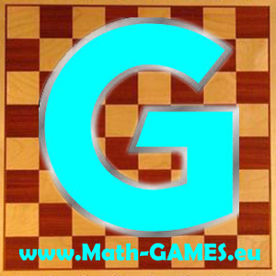**INVITATION**

**I invite you to the second meeting of the Erasmus+ project:**

**Math-GAMES - Games And Mathematics in Education for adultS Compendiums, Guidelines and Courses for Numeracy Learning Methods Based on Games (2015-1-DE02-KA204-002260)**

Each partner has to send his coordinator who must speak English. More persons are welcome.

**Programme**

Date: Friday, 26rd of February to Monday, 29th of February 2016

Place: Kalamata

Hotel: Hotel Flisvos, Kalamata, http://www.hotel-flisvos.gr/index_en.html

Airport: Athens International Airport (Athens), http://www.aia.gr/

**Website** [**www.math-games.eu**](http://www.math-games.eu)

**Aims of the meeting**

- evaluate and modify the first output (O1 Compendium)

- talk about the working process including the first quarter reports and the administration,

- discuss about the output O2 Guidebook

**Timetable (subject to modification)**

**Fr 26.02.2016 Arrival Day**

Prior to your arrival, inform us about the duration of your stay, to book rooms in Hotel Flisvos. The price per night including breakfast is 50 EUR for two persons in a double room and 40 EUR for one person in a single room.

**19:00:** Get-together, whoever is already there, in a traditional restaurant.

**Sat 27.02.2016 First Working Day**

**09:30** Meeting at the hotel lobby

**10:00** **Work time**

* The coordinator will make a short presentation about the progress of the project
* Each country will present their chapters of the output O1
* Discuss changes, corrections, improvements
* Discuss the next output (O2) and the coming timetable

**13:00** Lunch

**13:30** Meeting goes on

**17:00** Expected end

**19:30** Dinner

**Sun 25.10.2015 Second Working Day**

Meeting at **09:30** in front of the hotel

**10:00** Work on project details

**13:00** Lunch

**17:00** short visit to town

**Mon 26.10.2015 Departure Day**

Best regards,

Dimitrios Kyriazis

2nd Gymnasium of Messini